Operational Concept Description (OCD)

United Direct Marketing

Team 9

Fall Semester
Chun-Ling Chen – Project manager/ Prototyper
Chun-Pei Su – Lifecycle Planner
Shao-yen Cheng – System Architect
Yuan-Chang Chang – Feasibility Analyst
Stewart Allen – IIV&V/ Requirements Engineer
Yen-Kuo Kao – Operational Concept Engineer

Spring Semester
Chun-Pei Su – Trainer / Document Maintainer
Shao-yen Cheng – Chief Developer
Stewart Allen – Tester / IIV&V / Quality Focal Point
Kelvin Zhu – Project Manager / Developer

5/3/2013

Version History
Date | Author | Version | Changes made | Rationale
09/27/12 | YKK | 1.0 | - Original template for use with United Direct Marketing v1.0 | - Initial draft for use with United Direct Marketing
10/10/12 | YKK | 1.1 | - Redraw Figure 1. Update Figure 3, Table 2  - Update staff names listing  - Update section 1.2, 2.2 | - Correction  - Bug fixing [7061]  - Requirement modification requested by the client. Bug fixing [7062]
10/13/12 | YKK | 2.0 | - Added section 3.2, 3.3, 3.4 | - Evolving the document to the status as Core Foundation Commitment package based on data from Winbook
10/23/12 | YKK | 2.1 | - Updated section 3.2.4, 3.2.5, 3.4.2 | - Bug fixing [7214] [7215] [7216] [7217] [7218] [7219] [7220]
11/03/12 | YKK | 2.2 | - Updated section 3.2 | - Bug fixing [7442]
11/19/12 | YKK | 3.0 | - Updated section 2.3, 3.3 | - Evolving the document to the status as Development Commitment
1/27/13 | YKK | 3.1 | - Updated section 2.3, 3.3 | - Fixing [8096]
1/27/13 | KZ | 3.2 | - Fixed spelling and grammar typos throughout the document  - Updated team member list with members from Spring semester | - Correcting typos  - Updating with new team roster
2/20/2013 | SA | 4.0 | - Changed from Architected Agile to Single NDI. Looked through the document to remove references to Architected Agile. | - Comments from the recent review that the team should switch to NDI.
3/31/2013 | SA | 4.1 | - Updating for IOC1 | - IOC1 due
5/3/2013 | SA | 4.2 | - Verify ready for IOC3 | - IOC3 due

Table of Contents
Operational Concept Description (OCD) i
Version History ii
Table of Contents iii
Table of Tables iv
Table of Figures v
1. Introduction 1
1.1 Purpose of the OCD 1
1.2 Status of the OCD 1
2. Shared Vision 2
2.1 Benefits Chain 3
2.2 System Capability Description 4
2.3 System Boundary and Environment 5
3. System Transformation 6
3.1 Information on Current System 6
3.2 System Objectives, Constraints and Priorities 8
3.3 Proposed New Operational Concept 10
3.4 Organizational and Operational Implications 12

Table of Tables
Table 1: The Program Model ...2
Table 2: Artifacts 6
Table 3: Capability Goals 8
Table 4: Level of Service Goals 8

Table of Figures
Figure 1: Benefits Chain Diagram 3
Figure 2: System Boundary and Environment Diagram
5
Figure 3: Proposal Approval Workflow 7
Figure 4: Entity Relationship Diagram for UDM system 10
Figure 5: New Proposal Approval Workflow 11

Introduction

Purpose of the OCD
This document provides, in detail, the shared visions and goals of the success-critical stakeholders of United Direct Marketing System. The success-critical stakeholders of the project are Samta Jain, as the president and owner of the company; the project manager, the project assistants, clients as users; Team 9 members in CSCI 577 2012, as the developer team.

Status of the OCD
The status of the OCD is currently at the version number 3.1 in the beginning of the development phase. The current system has been analyzed and the operational concept of the current system has been assessed. The scope of the new system is to improve the process of building up projects and turn whole programs into an integrated internet system. The document is updated as per the exit criteria of the Foundation Commitment Review.

Shared Vision

Table 1: The Program Model

Assumptions
．Clients needs more convenient methods to access projects.
．Increasing sample project requests from prospective clients.
Stakeholders  (who) | Initiatives  (What) | Value Propositions (Why) | Beneficiaries  (For Whom)
．Developers,  IV &V  ． Graphic designer  ．UDM(company)  ．Project manager  ．Client  ．Prospective Client  ．Project assistant | ．Develop virtual encrypted link to micro website  ．Automate personalized project webpage buildup procedure  ．Advertise successful client cases to public  ．Exhibit periodic advertisements to public  ．Provide training project assistants | ．Faster project process  ．Increase the brand equity of UDM(company).  ．Strengthened competitiveness of UDM(company). | ．UDM(company)  ．Proposal manager  ．Client  ．Prospective Client

Benefits Chain

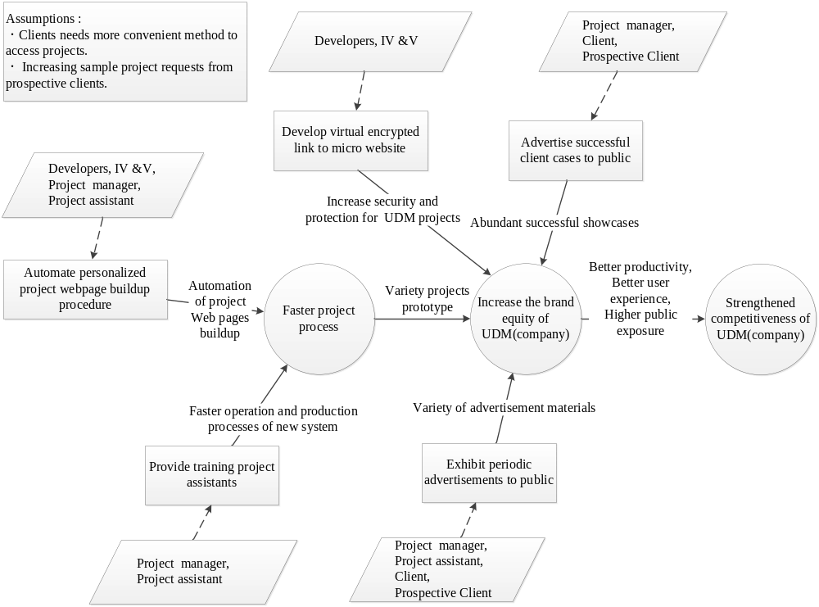
Figure 1: Benefits Chain Diagram

System Capability Description
- The UDM system is a web based service both applied to inside the intranet of the company UDM(United Direct Marketing) and publicly to clients.
- The target customers for the system are both employees at UDM and clients.
- The UDM system is able to provide a customized web page for each client and personalized proposal for client review and comment.
- The UDM system is able to provide a listing of archived advertisement.
- The UDM system is able to provide a subscription to an e-newsletter.

System Boundary and Environment
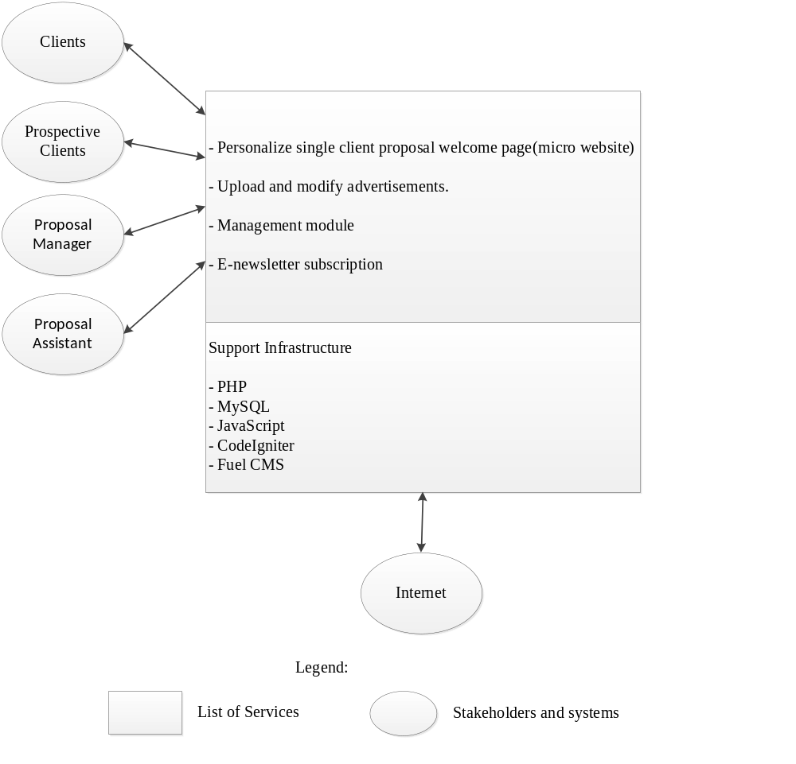
Figure 2: System Boundary and Environment Diagram of United Direct Marketing System

System Transformation

Information on Current System

Infrastructure
The client subscribes a web host plan from Newtek Network Services (http://www.thesba.com/). The current website system is running on that web host. The software platform of the current website system is Coldfusion 10 running on Windows Server. There is a database used inside the company now which is MS Access connected through JDBC+ODBC. On the other hand, employees in the company at this moment use only email to deliver proposals to clients and receive modification information. In other words, website and proposal procedure are now in different and unrelated environments. The web host can support PHP and MySQL.

Artifacts
Table 2: Artifacts

Artifact | Description
Hand-picked proposal procedure | The only way to produce a proposal right now is to copy from an old file and customize the client information on it.  Although proposals provided from UDM are very alike from one to another at the moment, there are no templates and no modular mechanism to automate the whole procedure.

Current Business Workflow

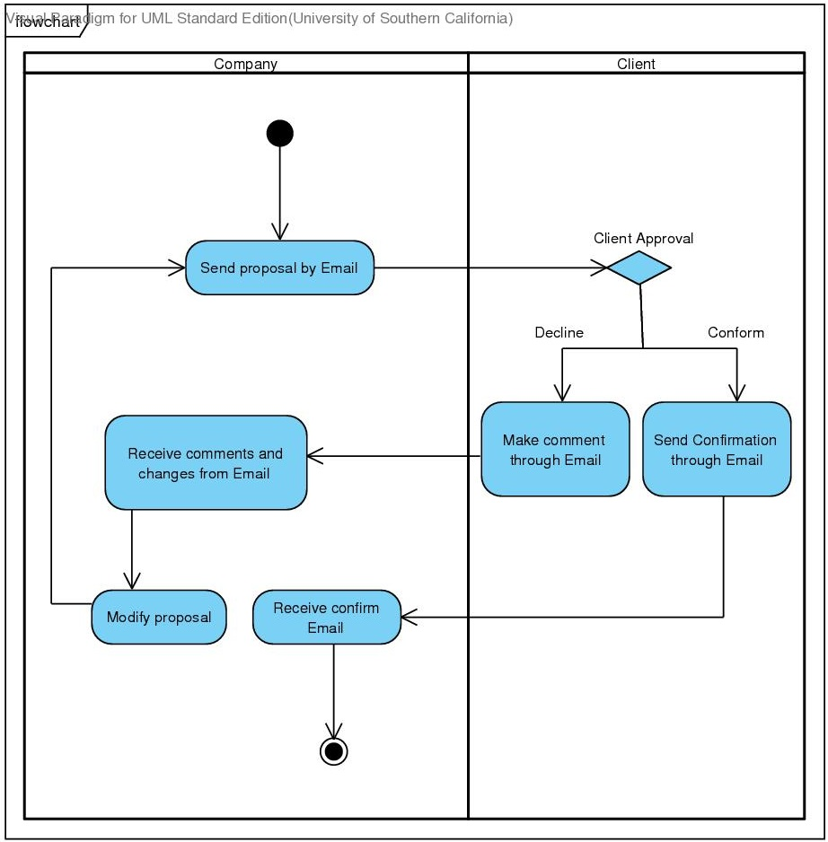
Figure 3: Proposal Approval Workflow

System Objectives, Constraints and Priorities

Capability Goals
Table 3: Capability Goals
Capability Goals | Priority Level
OC-1 Micro Website Generation: The system is capable of building micro website so customers may see the proposal document and related marketing content from the webpage. | Must Have
OC-2 Related Projects Showcase module: The additional module is capable of posting related proposal content on the micro website. | Must Have
OC-3 Micro Website Administration: The backend system provides the ability to modify the webpage without help from a software developer. | Should Have
OC-4 Content Search Module: The module provides visitors the ability to search the contents on pdf and webpage. | Could Have
OC-5 Email Subscription: The module provides visitors the ability to subscribe to a periodic e-newsletter. | Should Have
OC-6 Encrypted Micro Website URL protection: The module censors the real URL, so only people with links from emails could access the site. Its main purpose is to prevent the proposal from being leaked out too easily. | Must Have

Level of Service Goals
Table 4: Level of Service Goals
Level of Service Goals | Priority Level | Referred WinWin Agreements
Cross Browsers Support: support IE 8 and above, Firefox 4 and above, Chrome 16 and above | Must Have | LOS-1

Organizational Goals
OG-1: Decrease the time to create the project via automation micro website buildup.
OG-2: Increase the brand equity of the company via advertising successful showcases.
OG-3: Strengthen competiveness of the company.

Constraints
CO-1 Keeping contract with original web hosting company NewTek: The host of the new system should be utilized in the original web hosting company in order to save money by keeping existing contracts with NewTek.
CO-2 Budget: The maximum budget for the whole system including graphic design and backend frontend is $2000.

Relation to Current System
Table 5: Relation to Current System
Capabilities | Current System | New System
Roles and Responsibilities | ．Project manager/assistants performing locally, repetitive procedure. | ．Project manager/assistants trained for online operation in the new system.
User Interactions | ．Project manager/assistants make proposal related communication by Email. | ．Project manager/assistants make proposal related communication through the new system.
Infrastructure | ．Batch data processing  ．Communication and process stored in email. | ．Interactive data Processing  ．Communication and process stored in the new system.
Stakeholder Essentials and Amenities | ．Project information is stored in Email and can only be viewed by specific person who has the Email account. | ．Project information is electronically stored in database and can be edited/viewed online by project manager.
Future Capabilities | ．Client information stored in local paper/ database. | ．Integrate client information to micro website database.

Proposed New Operational Concept

Element Relationship Diagram
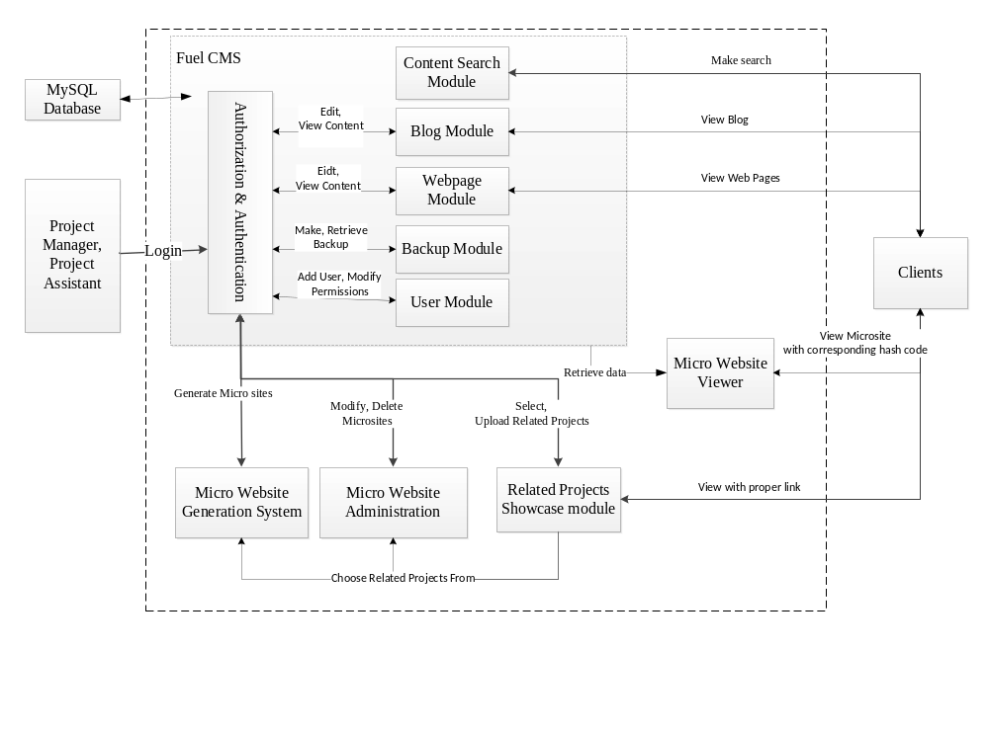
Figure 4: Entity Relationship Diagram for UDM system

Business Workflows
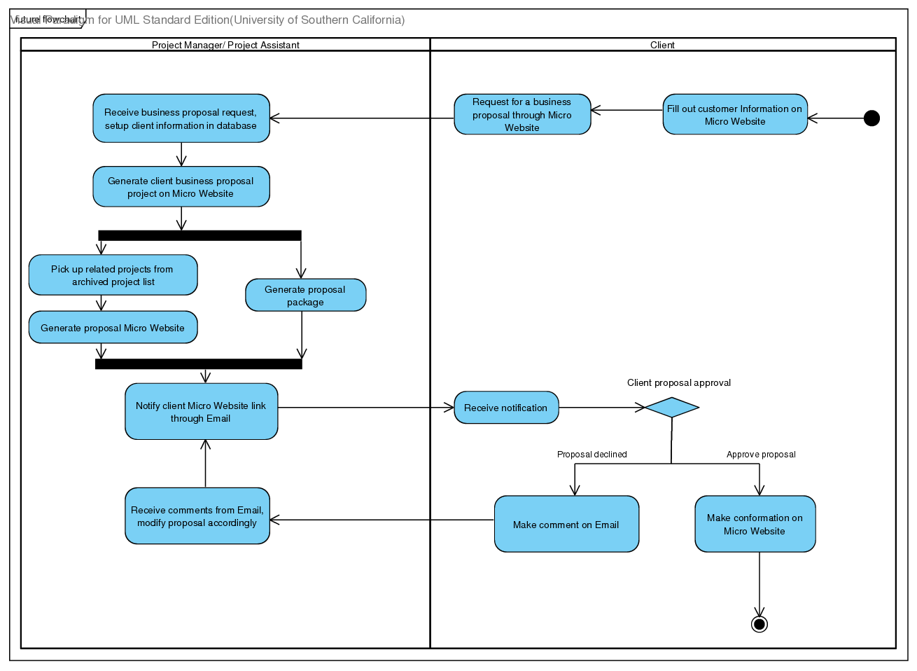
Figure 5: New Proposal Approval Workflow

Organizational and Operational Implications

Organizational Transformations
- The project manager needed to be trained to create project micro website through the new system.
- The project manager and assistants can access the whole proposal project anywhere through a web browser.

Operational Transformations
- Micro website generation of the new system will automate the process of project buildup web pages, and the whole project is demonstrated in the micro website but not demonstrated in one Email as before.
- Hiring more assistants to help and share the work load.

